LRM FAQ, Know Issues Work-arounds, Tips and Tricks
I forgot my password! 4
I need to report an issue to the NRS Helpdesk 4
I Get a ‘Server rejected the connection’ Error message when I try to Launch LRM via Citrix. 5
I Get ‘The username and password combination supplied is not valid.’ When I Attempt to Log into LRM. 5
I Get ‘An error occurred while loading core services from the database’ Message When Attempting on Log into LRM. 5
Road Module Data Entry 6
I am getting a Reconcile Error when I try and post my changes. 7
I’m getting an ‘ORA-01013’ Error 8
I’m getting an ‘Error in Gateway’ message when attempting to open Spatial View 8
I’m getting an ‘Error Load Layer File’ message when I try and open Spatial View 9
Spatially updating a Road in LRM – Road Tenure procedure 10
Road FTA submission error – length issue 10
Road FTA submission error – Amendment Type for NEW tenure submission 10
Road FTA Submission error – Road Name can’t exceed 20 characters 11
RESULTS submission validation failure – The content of element ‘rst:tenureKey’ is not complete…..cutblock is expected 11
Gross Licence Area not updating at the Licence Level 12
Map Manager minimizes/disappears and becomes unresponsive 12
Map Manager and/or ArcMap freezes when I try and File-Export (or Save my mxd) 13
MS Access issues - RESOLVED: 13
Issue Populating Harvest Units 14
When I try and open an Attribute Table in Spatial View/ArcMap nothing happens 14
What do I do if LRM is unresponsive? 14
I am trying to open an MXD I used in Geo and all of my layers are broken 15
How do I open an ArcMap session from LRM? 15
How do I add new tools to a toolbar in LRM? 16
Why can’t I edit layers in Spatial View? Only Temporary Line, Point and Poly are available for editing. 17
Why Can’t I Edit the Road Layer in Spatial View? 18
Why can I only digitize one feature at a time in an edit session? 18
How Can I Edit Non-SDE Spatial within LRM (Shapefile, FGDB etc)? 19
Map Manager Template Tips 22
I need to make changes to a map template before I export to PDF. 22
I would like to suggest a change to a Map Template 23
Site Plan Comments for Results and Strategies not populating on Site Plan Report 23
Unable to Select Stocking Standards 24
Unable to Save Edits Due to Existing Overlap Issue 25
Intersecting Road Violation 26
Unable to Insert a Cutblock Shape record on the Block child tab 27
New LRM Users name does not appear in Responsibility dropdowns - RESOLVED 27
Cannot add Road Activity Completed Date without Populating Actual Costs – RESOLVED? 27
Management Unit Record for Road Does Not Have the Correct TO Value 28
Overlay Features missing when trying to Populate 29
Populate failure 30
LBE spatial Error when trying to edit 31
Running route event wizard prompts LBE Spatial error 33
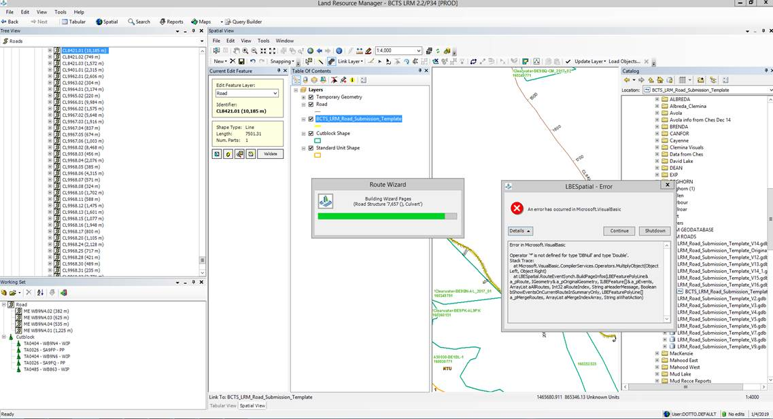 33
Solution: Check the road structures and if there is a type field defined in LAT LONG (string or decimal) but no corresponding values in the latitudes and longitudes, that is the problem. This seems to be a problem with older roads and LRM doesn’t know how to deal with it. You can either delete the type or enter lats and longs to resolve the issue. 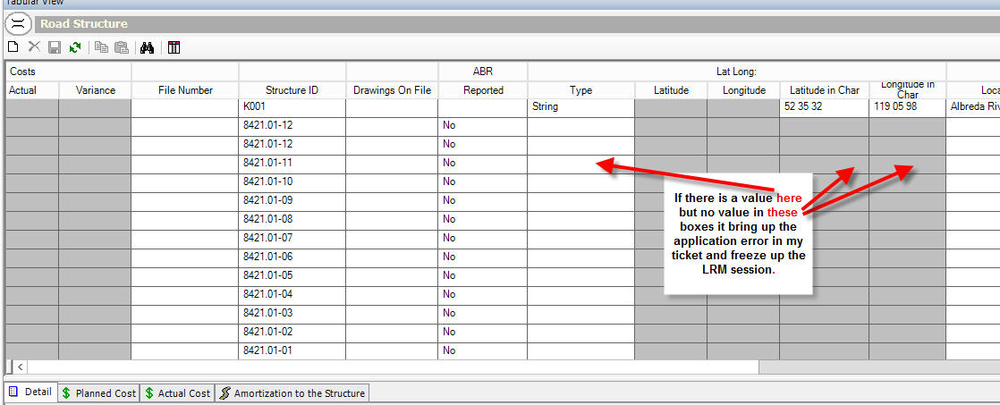 33
Application error when trying to update a road record 34

I forgot my password!
This is the number one help desk request for the LRM application at the moment. Please read the following document to familiarize yourself with the different logon credentials required and what they mean. Follow the recommended best practices in this document with respect to passwords. If you have simply forgotten your LRM password, please contact your local BA LRM Admin first (Candice Steinke/Daniel Otto) for a password re-set. If you have attempted your password too many times (10) and have been locked out, you will need to contact the NRS helpdesk to unlock your account. If this has happened you will likely get an message when trying to log in that ‘combination not valid’.
ftp://ftp.for.gov.bc.ca/TKA/external/!publish/GENUS/Passwords Passwords Passwords.docx
Please also remember that your password for TRAIN, TEST and PROD are not the same. If you did not change your password in the TRAIN/TEST environment it should still be your IDIR ID in ALL CAPS.

I need to report an issue to the NRS Helpdesk
Remember your first line of support should be your BA LRM contacts:
Jessica Gunn – UDUTU/LRM Access
Candice Steinke/Daniel Otto – LRM password reset (if not locked out), Road Module questions/issues
Derek Pue/Candice Steinke/Daniel Otto – Spatial View/ArcMap questions/issues
Kari Doyle – Silviculture Module questions/issues
Johnna Wandler – Block Module questions/issues (and Silviculture if Kari is unavailable)
Ryan DeVisser – Contract Module questions/issues
Lorne Wood – Certification Module questions/issues

If you still can’t resolve your issue, submit an NRS ticket. Please include as much detail about your issue as possible. This includes (but is not limited to):
- What environment you are working in: PROD, TEST, TRAIN
- What server you are working on – look in Citrix Connection Centre to determine server name
- What module you are working in: Blocks, Roads, Silviculture etc.
- What steps you took leading up to the issue/error.
- Include screenshot of your entire LRM screen, not just the error message window.
- Where an error message is displayed, click the Details button to expand the error message prior to screen capture.

I Get a ‘Server rejected the connection’ Error message when I try to Launch LRM via Citrix.
This error is usually due to an older version of Citrix Receiver installed on your PC. Even if you are using the gateway via dts.gov.bc.ca to launch LRM, you still need to have the latest version of Citrix Receiver installed on your PC. 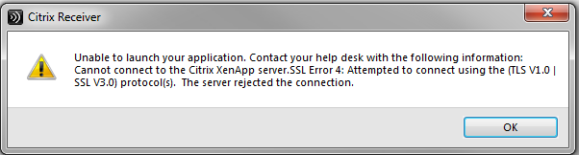
For instructions on how to download Citrix Receiver see the following document:
ftp://ftp.for.gov.bc.ca/TKA/external/!publish/GENUS/Passwords Passwords Passwords.docx

I Get ‘The username and password combination supplied is not valid.’ When I Attempt to Log into LRM.
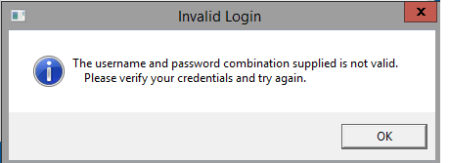
This error usually comes up when a user has attempted to log in too many times with an incorrect password and has been locked out of the application. To have your account unlocked you need to contact the NRS Service Desk @ 1-866-952-6801

I Get ‘An error occurred while loading core services from the database’ Message When Attempting on Log into LRM.
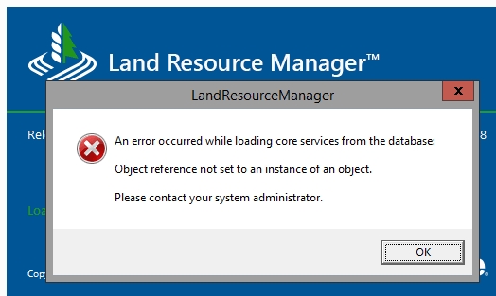
If you encounter this error when attempting to log into LRM you will need a Panel Reset. Any LRM ADMIN can do this. Candice Steinke and Daniel Otto are both ADMIN for TKA. If neither of them are available you can also call the NRS helpdesk and request a Panel Reset, but they may not understand what you are talking about. Here are the instructions for resolving this:
Go to the _UserPanelState table in the Validation tables and finding the username for the affected person in the table and renaming their USER_NAME. Just add an _XXX or _bad or something and save the record. Next time the user logs in it will then create a new record automatically. If you are an ADMIN and are experiencing the issue you will obviously need to find another ADMIN to do this for you.
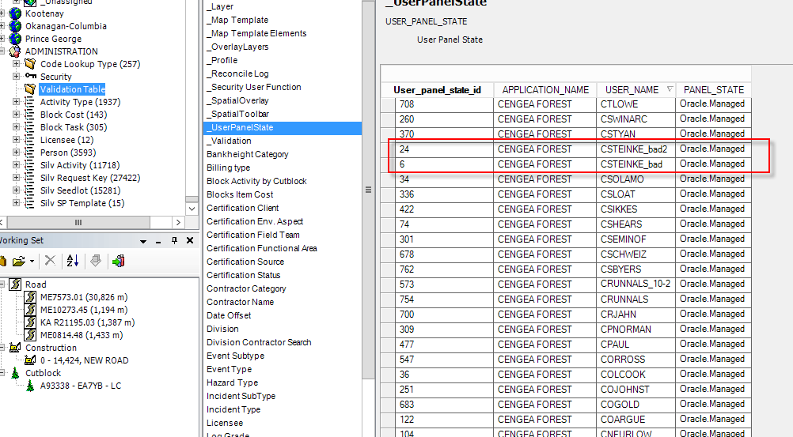

Road Module Data Entry
For all road-related data entry for the Kamloops Business Area, please follow the local Road SOP document as far as what content to enter where. Use the UDUTU training workflow/videos as a guide only on how to navigate around in the road module, but for specific data entry requirements DO NOT follow the instructions in the videos/workflows.
The Road SOP document has not yet been updated for LRM, but our business process has not changed. So screenshots in here will not be correct. We will be working on updating this documentation over the next several months. In the meantime continue to use the document as a guide as is.
ftp://ftp.for.gov.bc.ca/TKA/external/!publish/GENUS/RoadsSOP_DRAFT_V13.pdf

I am getting a Reconcile Error when I try and post my changes.
There have been changes made to the BAWF09 – Post and Reconcile workflow in UDUTU under the Basics Learning Path that describe how to resolve a Reconcile Error. Please review.
BAWF09 - Post and Reconcile
Reconcile a Posting Error
3.1. Right click on the database icon in the bottom right that is red and indicates there is a reconciliation error.
3.2. Click on cancel in the Version Console to Cancel the Error.
• DO NOT click on Refresh Version, this will remove any edits you have created during your editing session.
3.3. Right Click on the database icon and choose Post Version.
3.4. The Reconcile Manager will ask you if you are sure. Click yes to post your changes. • You can also click the Don’t show this message again if you do not want to see this message in the future. 3.5. When posting is occurring the message will say pending reconcile in the bottom right corner, once complete it will go back to Green – No Edits.

The video in UDUTU at the end goes over this process as well.
Most times it is a false error. Here are a few other things you can try if the above does not resolve it:
- Right click on the version in LRM and choose the 'display version name' option
  - This should cause the message to update to 'No edits' most of the time.

- If this doesn't do the trick, then take this step.
  - 1 Navigate to any editable context
  - 2 click on insert to create a new row
  - 3 click on the refresh button - the new row will be removed and the version label should reset to 'No edits'"
If you try all of this and your Reconcile Error will still not resolve try logging out and back into the application. If that still doesn’t resolve the error, you should submit an NRS ticket and cc Peter McBride (peter.mcbride@gov.bc.ca). Include a screenshot of the Reconcile Error from the Version Console screen with details expanded as there can be some helpful messaging there that can help them determine the cause of the error. There can be many reasons why these errors occur.
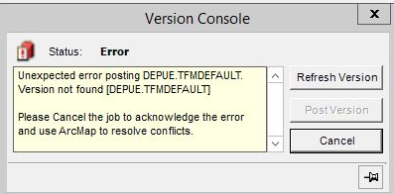

I’m getting an ‘ORA-01013’ Error
This error has been reported and is related to the performance issues we have been experiencing since go-live. If you encounter this error above (not all Oracle errors, but this 01013 one specifically) we are told this is happening when the database server is unable to handle the request – too much traffic is one potential reason. Since the Database Server upgrade we should no longer be experiencing this issue. If it occurs again, please submit a new ticket to the NRS helpdesk. Wait a while and try performing your task again later.

I’m getting an ‘Error in Gateway’ message when attempting to open Spatial View
This error message seems to be cause by a user having a special character in their LRM password. Although the system will allow you to save your password with special characters (!@#$% etc), when a user tries to open the Spatial View they will encounter this error. To resolve change your password to something with only letter and numbers.
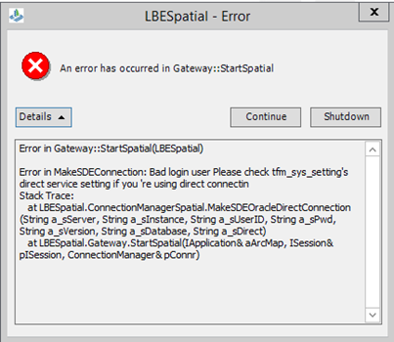

I’m getting an ‘Error Load Layer File’ message when I try and open Spatial View
This error may occur from time to time when trying to load spatial view.
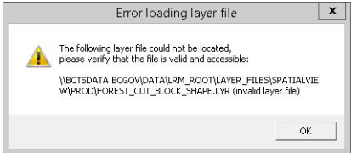
The layer files being referenced in the error messages do exist but this has something to do with the user’s profile. To fix this complete the following steps:
- Close Spatial View via the File menu within the Spatial View window (File – Close Spatial View). Do not just hit the X in the top right corner of the spatial view. This doesn’t actually close the Spatial View, it only hides it.
- Once Spatial View is closed go to Tools – Options from the main menu.
- Click Spatial View in the tree on the left
- Click the Purge MXD File… button
- Click Yes.
- Click Layers under Spatial View in the tree on the left
- Click the Purge Local Files button
- Click OK
- Re-open your Spatial View and reload layers as needed.

Spatially updating a Road in LRM – Road Tenure procedure
When you want to submit a spatial change to FTA, not an FSR road transfer – for example, a POC was moved:
Once spatial changes are done and linked in LRM,
Create a new Road Tenure with the next consecutive amendment number.
Then you need to find the Road Tenure that had the last amendment of that road section. In the old amendment, in the Road Tenure Section Detail record, set Reassign Permit field to Yes. Now you can edit the neighbouring field Permit Id to be the new amendment (ie. 8421/04). It will move it there for you.
Proceed to submit new amendment to FTA

Road FTA submission error – length issue
Due to a change in how event data is rounded in LRM many roads that were entered into Resources spatially will throw an error when sent to Report Manager to generate an xml for an FTA submission. Temporary work-around: – amend the To Station value for the Road Tenure Section record to round down by 1 meter. Generate xml for road using Report Manager.

Road FTA submission error – Amendment Type for NEW tenure submission
There is currently an issue where the amendment type is populated in error in an xml for a brand new road permit or FSR submission. When the xml is submitted to ESF/FTA the following error will be returned.
[1827] Unexpected error occurred inserting ROAD_PRMT_AMEND.
[414] ORA-02291- integrity constraint (THE.RPA_RATCD_FK) violated - parent key not found

This should be fixed in the next patch release. In the meantime users will need to edit the xml to remove the entire amendmentType section in the XML:
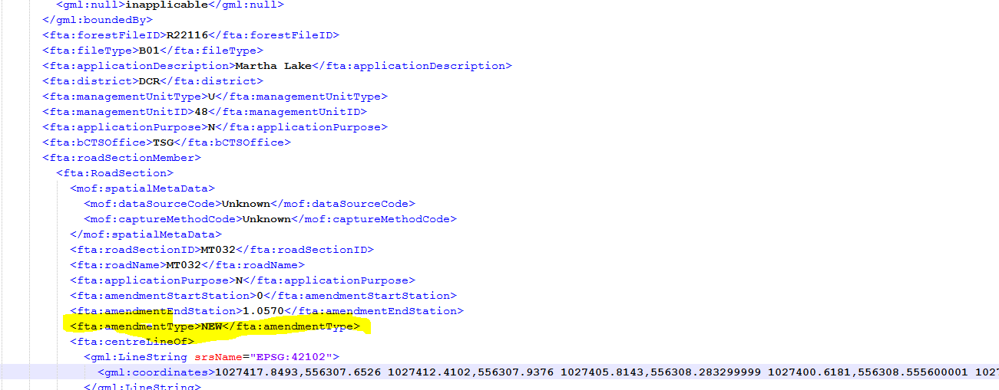
NOTE: This is for BRAND NEW Road Permit or FSR projects only, not amendments to existing tenures.

Road FTA Submission error – Road Name can’t exceed 20 characters
There is currently an issue where FTA rejects a submission when a road name value exceeds 20 characters. This was never an issue with FTA prior to LRM so it is suspected to be an issue with LRM and not FTA. This has been reported. Unsure of any work-around aside from renaming the road to under 20 characters.

RESULTS submission validation failure – The content of element ‘rst:tenureKey’ is not complete…..cutblock is expected
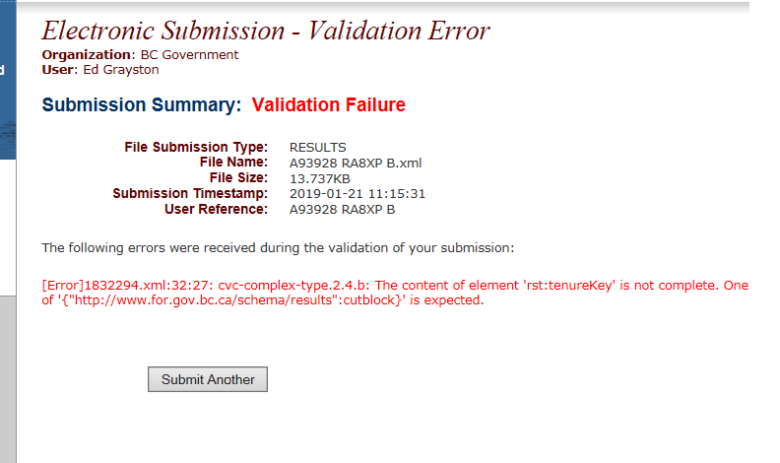

XML containing rst:cutblock XML missing rst:cutblock
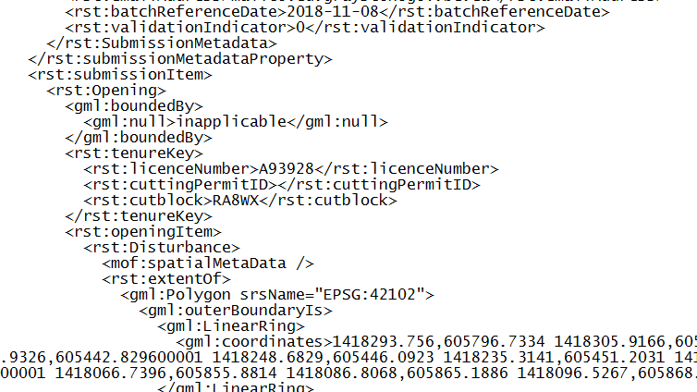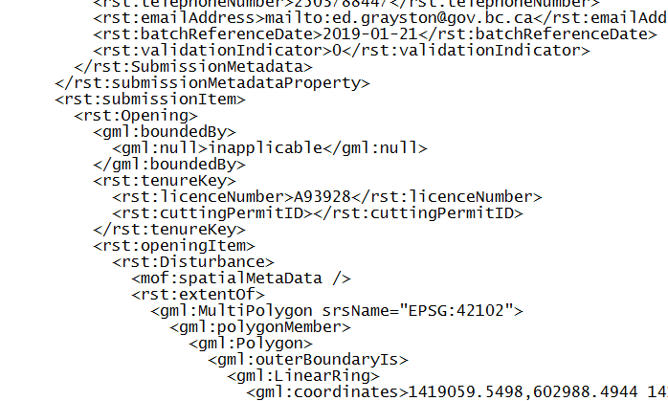
This error is occurring when the Block Nbr field is blank on the Cutblock context (even when the child record Block Identifier for Silviculture Reporting field says the Block ID field should be used). This results in the rst:cutblock line missing in the xml. The work-around is to copy the Block ID to the Block Nbr field and re-create your xml report. Another potential issue that we haven’t get encountered will be when the Block Nbr field is already populated with the original planning blob number……the xml will generate with the wrong block id in this case. This is something to look for and you will have to alter the xml to update the cutblock to the Block ID instead of the Block Nbr.

Gross Licence Area not updating at the Licence Level
There is an issue where the gross licence area may not update correctly when you make a change to one of the blocks within that licence. This is a known issue that is being looked into but for now here is the work around.
- Identify the block causing the area miscalculation by comparing the gross area of the blocks as they appear on the blocks tab at the licence level to the gross area of the blocks at the block level. You should identify at least one block with mismatching areas
- Navigate to that block on the block level and in the ‘Block Allocation’ tab move the block to an unassigned licence. Save changes, post version.
- Navigate to the block on the unassigned licence and switch it back to the correct licence, save and post version.
- Compare the two areas again, you should notice that the area at the licence level has updated to match the combined areas of the blocks on that licence

Map Manager minimizes/disappears and becomes unresponsive
Some users are experiencing issues with Map Manager ‘freezing’ or disappearing. Usually Map Manager attempts to start and then disappears from the screen. The LRM icon and Map Manager icon can still be seen on the users Task Bar, but when they try and bring them back up they are not responsive. This issue has been reported and they are working on a resolution. In the meantime a work-around that usually resolves this is to temporarily turn off the display of your secondary monitor.
- Switch to your desktop (click the Windows key and the D key together on your keyboard).
- Right click on your desktop and choose Screen Resolution.
- Change The Multiple Displays dropdown to show desktop only on 1 (see screenshot below).
- This will force all of the applications to be displayed on your primary monitor. The Map Manager usually re-appears.
- You can then switch back to 2 monitors immediately and can still run Map Manager.
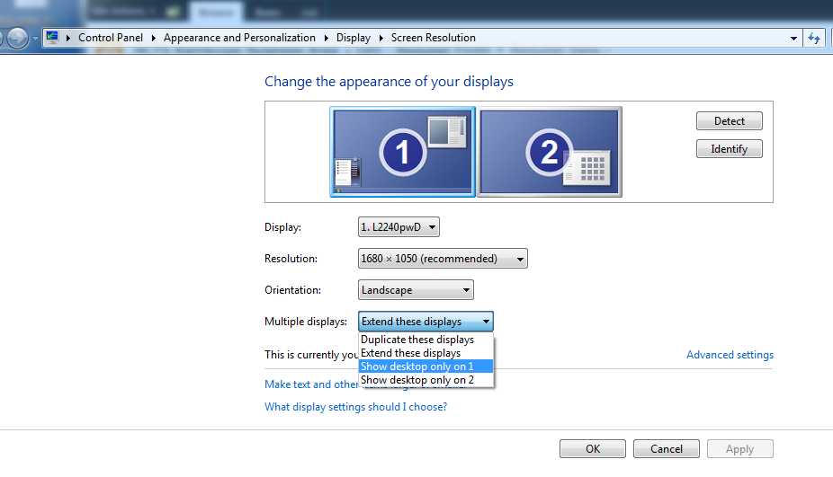

Map Manager and/or ArcMap freezes when I try and File-Export (or Save my mxd)

This is a known issue and is only affecting some users. It is suspected that is may have something to do with Citrix display settings and only seems to affect users with higher end NVIDIA brand graphics cards). This can be resolved by switching to a Windows display rather than a seamless display in the Citrix display settings, but that results in the windows within windows situation that is not ideal for using the LRM application on multiple screens. We have multiple departments currently looking into a better way to resolve this issue. In the meantime, a script tool has been created that will allow you to export your map to PDF. The tool is located here:
F:\!shared_root\Python\LRM_Tools\ExportToPDF
You can also search for the export tool in the ESRI toolbox and just run that tool. It is only exporting via the File – Export method that seems to be the issue as the GUI seem to be unable to be displayed.
Another option is to save your mxd project and attempt to export from another workstation or laptop if possible. For BCTS staff, if you have access to the GTS desktop, you can open the mxd there and you should be able to export.

Data Driven Pages doesn’t export correctly ArcMap LRM

MS Access issues - RESOLVED:
There are currently still issues with accessing and running Ad Hoc reports from MS Access. The database admins are working to resolve the issues but no ETA has been provided.

Issue Populating Harvest Units
An issue has been reported where the populate function is scrambling the harvest units in a block with multiple SUs…..the RRZ becomes linked to the productive SU area instead of the RRZ area. This does not happen consistently but it has been reported to NRS.
This error sometimes prevents the populate from working at all.
A work-around is to delete any existing Harvest Season, Method and Strategy spatial using an edit session in spatial view (delete spatial) and then re-link the spatial for these records (make sure you export the features to shapefile prior to deleting them if you don’t have access to the original data). Populate seems to work even after the same shapes are re-linked.
Another issue populating HU’s resulting in error message below was solved by buffering streams for MFZ without end caps to create HU spatial. Have to use geoprocessing buffer tool not one on Editor menu.
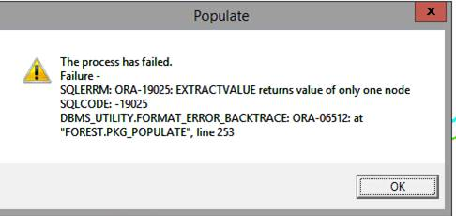

When I try and open an Attribute Table in Spatial View/ArcMap nothing happens
I have had this issue too and spoke with a couple of other GIS staff this week who have as well. We eventually discovered that the table was up in the very top left corner of our screen.....like a tiny grey speck. Sometimes you can grab it and move it down. If that doesn’t work or you can’t see it at all, others have had success temporarily disabling their secondary monitor from the screen resolution settings on your desktop. This forces all applications to your primary monitor. You can then turn your secondary monitor back on again right away and the window will stay put (at least for your current session). This is a work-around for now and there are a couple of on-going issues being investigated around dual monitors and resolution settings in Citrix.

What do I do if LRM is unresponsive?
Be patient and recognize the difference between unresponsive and slow performance. Often the application will display Not Responding messages at the top of the window when it is just thinking hard. Before you resort to killing an LRM session make sure you leave it for an adequate time to try and perform the task…..sometimes this could be 10-15 min depending on what it is trying to do, network traffic at the time etc. If you are ‘frozen’ for longer than 20-30 min then you can safely assume the application is truly not responding and you can kill your session.
Best practice to kill an LRM session that is not responding is to first go to the Citrix Connection Centre (click up arrow beside clock in the bottom right corner of your screen, right-click the citrix icon and choose Connection Centre).
From there select the server name that you are connected to (ZNEN, GEELY, GILERA etc) and then click Log Off. This will force the application to close and log you off that server. Once the server name has completely disappeared from the connection centre screen then you can log back into the application. Do not Disconnect or when you log back in you will just be re-connected to the same frozen session!
This usually works, but if it doesn’t then you can try the Task Manager next, but when you use the task manager to kill your session it may not log you off the server right away and that’s why you may be unable to log back in right away.

I am trying to open an MXD I used in Geo and all of my layers are broken
Any mxd that was created in ArcMap prior to LRM that references our BCTS SDE data will have broken layers. When we switched to LRM, the database structure was changed so we no longer have separate datasets for every Business Area. As such the old layers/layer files will no longer work as the datasets no longer exist as they were. When you try an open on of those MXDs in LRM ArcMap you will find that they can take a very long time to open because it is searching for data that no longer exists. We recommend you don’t try to open these mxds. If possible use the new LRM provincial templates and re-create your map from Map Manager.
If you can’t re-create the map using Map Manager, we have a tool/script that can be run on any mxd that will strip any broken layers from the mxd and create a list of all of the layers removed.
Tool: \\bctsdata.bcgov\data\!shared_root\Python\FindingBrokenLinks
You can then open the MXD quickly and then add back in new LRM layers to replace the ones that were removed. Keep in mind though that the LRM layer files may look quite different than the symbology we had for our layers previously. We may have also had layers in our templates that don’t exist in the LRM layer files today. We are working on restoring some of the layers/templates that we used to have in Geo. This is not 100% complete but the following folder has all of the BCTS SDE layers from our old Geo environment with the old symbology preserved, but updated to point to our new LRM production database. Everything except the road layers have been re-sourced so far.
F:\tka_root\Library\Templates\Template_MXDs\GEO_LayerFiles\LayerFiles

How do I open an ArcMap session from LRM?
NOTE: ArcMap is no longer available via the Tools - Additional Tools – ArcMap menu. It must instead be launched via Map Manager. There are various methods to do this, but the quickest and most reliable is this:
From the Maps button click the dropdown arrow. Choose 1 Empty – Empty Map
Once the Empty Map opens in ArcMap go to File – Open and browse to find and open your desired MXD.
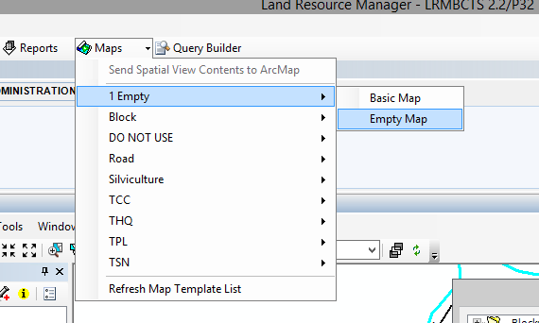

Note: You cannot edit BCTS SDE data from ArcMap. All spatial editing of corporate SDE data must be done via the Spatial View.

How do I add new tools to a toolbar in LRM?
All editing should be performed using the default LRM Editing Toolbars provided. If a user attempts to add a tool via the customize menu and they are not authorized to do so, they will see the popup displayed below. Your LRM password will not work here. Only BCTS GIS staff within the GIS_Admin security group have the authority to add new tools to toolbars in Spatial View/ArcMap and they can only do this for their own LRM account, they cannot be shared with other users.
The GIS task team is working with Trimble to add some additional tools to the LRM Editing Toolbar, as well as create a new toolbar with a handful of common tools that all GIS users would have access to. These tools all have to be tested and approved in the test environment prior to being brought into production, so this process could take some time.
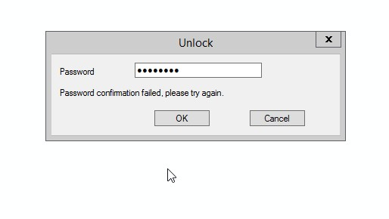

Why can’t I edit layers in Spatial View? Only Temporary Line, Point and Poly are available for editing.
When you first log on to LRM at the log in screen when you enter your credentials there is a dropdown for you to select the Arc License type you want to use. If you are going to be doing any linking/digitizing you will need to select ArcEditor. If you try to edit and you only have an ArcView license selected you will not see any of the BCTS layers listed in the Edit Features dropdown menu. To change your license level once you have logged in you need to close Spatial View via the File menu within the Spatial View window (File – Close Spatial View). Do not just hit the X in the top right corner of the spatial view. This doesn’t actually close the Spatial View, it only hides it. Once Spatial View is closed go to Tools – Options from the main menu and select License under Spatial View on the left and then choose ArcEditor from the ArcGIS License dropdown. Click OK to save your changes. Re-open your Spatial view window and you should now be able to edit.
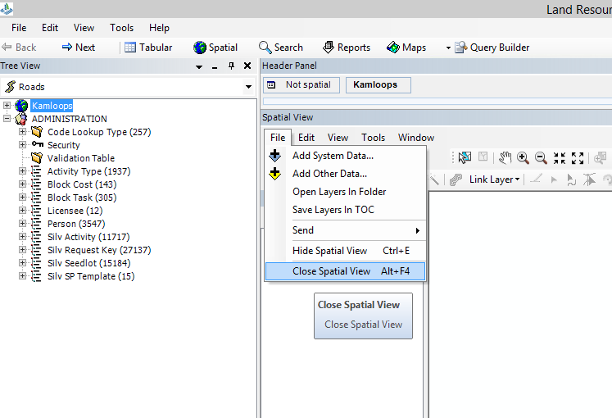
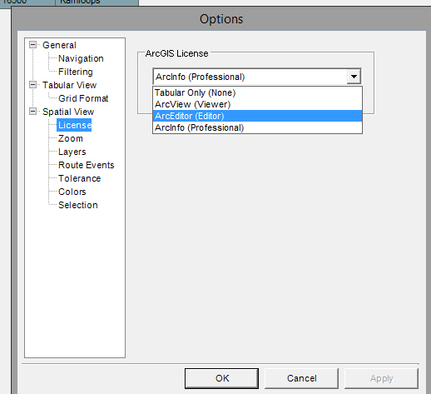

Why Can’t I Edit the Road Layer in Spatial View?
Only BCTS GIS staff and GIS contracting staff who have completed the Road Editing training in UDUTU have the ability to edit road spatial data at this time. We ask that GIS contractors only add/edit new roads in LRM. For any road edits required to existing roads, please submit a GIS request: https://spc-bcts.gov.bc.ca/BCTS_TKA/Lists/GIS%20%20Request%20Form1/AllItems.aspx
There measures are in place as there are some new road editing tools that are complicated and have potential to introduce errors into our tabular road data if not used correctly.

Why can I only digitize one feature at a time in an edit session?
The LRM application is designed to edit single features that are tied to tabular records in the database and apply certain business rules and spatial validation rules to ensure data being entered is clean/correct. Unfortunately this means a user can only edit/digitize one feature at a time in an edit session. When adding data such as GPS Hubs, cruise lines/points this is obviously not an efficient method to add data. For direction on how to bulk load data into the non-managed SDE datasets, please refer to the GIS workflows in UDUTU: GBWF21 – Editing Unmanaged Data
Note: The Load Object tool as shown in this workflow on the LRM Editing Toolbar appears to be missing in PROD. This has been reported and will hopefully be resolved soon.
*Users have also been reporting that they don’t see the copy/paste button on the LRM Editing toolbar. If you experience this please contact Candice Steinke, as we are trying to figure out why some can see them and others cannot.

How Can I Edit Non-SDE Spatial within LRM (Shapefile, FGDB etc)?
A user cannot edit local files from Spatial View or Map Manager within LRM. In order to edit a local file the user must launch a stand-alone ArcMap session. See instructions below:

Map Manager Template Tips
Reminder-the first word of the Map name indicates which shape must be selected for the map to run properly. For example: Block Harvest Plan Map *Must have a Block Shape highlighted and Licence Location Map *Must have a Licence Shape highlighted. If you try and create a Block map using the License spatial or visa/versa it will probably work, but the tagging in the legend will likely NOT work was intended.
The Schedule C/R Road Construction maps are located in the Map Manger in the Road folder but are prefaced with BLOCK as they are intended to zoom to a block and display all of the roads associated with that block on the map. The map will not work if you try and zoom to a road.
When sending to Map Manager from the tree view, always send from the Block shape record in the tree and not the Block tabular record. This will ensure that when you export directly from Map Manager to PDF via the Finish button that the correct pdf file name will be applied. This does not matter if you export manually from preview as you will be required to manually name the output PDF in that case.
Also remember all of these map templates include both TRIM Water Lines and BCTS Stream layers. For TKA because our stream layer contains a copy of ALL TRIM streams, the TRIM stream layer needs to be turned off for every map that is created for TKA. Failure to do this will often result in duplicate/criss-crossing stream line work on your maps. To accomplish this you will have to Preview the map from Map Manager and File - Export from ArcMap to create the pdf (Do not use the Finish button on the Map Manager window or it will not keep any changes you made in the preview.)
For any map templates created for our Cascades field team (Merritt/Lillooet), if the template contains the provincial OGMA layer it will need to be replaced with local OGMA layer. A layer file can be found here:
F:\lrm_root\layer_files\Prod\!BA_Folders\TKA\Local Data\OGMA_Cascades.lyr

I need to make changes to a map template before I export to PDF.
The existing Map Templates were created for everyone in the province to use. As such, they do not include any local BA specific datasets that we may have used on our Geo templates. You can Preview the map from Map Manager and make any changes you need to make from the preview session in Arc. This includes adding/removing layers, turning layers on/off in the TOC and making any changes required to the legend. Once you are satisfied with the changes you will need to File – Export from the Preview (or run the export script if you have issues with exporting). Do not click Finish from the Map Manger window or it will export to PDF but you will lose all of the changes you made. You may also want to File – Save and save a copy of your mxd from the preview in case you need to go back and make further changes later on.
NOTE: A few users are experiencing an issue with ArcMap ‘freezing’ upon File – Export (and File – Save) from preview or from an ArcMap session within LRM. This issue has been reported. It seems to be related to a user’s graphics card. See issue documented above in this document.

I would like to suggest a change to a Map Template

All of the existing Map Templates in the Map Manager have been created by a provincial template task team and were reviewed by the LRM Block, Road and Silviculture task teams for content. We do expect that as people get using them there will changes that need to be made to some of the symbology/layers to make the maps more legible/useful. There may also be the need to add additional layers to certain templates that we may have missed.
UPDATE: The template task team has completed the first round of template amendments based on feedback from staff. The LRM template task team has now been disbanded and any template changes will be actioned by the GIS Advisory Team (GISAT). Please submit any template change requests you have to Candice Steinke via e-mail. Your suggestions will be passed along to the GISAT for review/action. The GISAT will also be responsible for creating alternate page size and orientation versions of template as needed. This may not be for every template.
Please include the following information in your request:
Category: Spatial View Layer or Map Template Layer
Change Description: What needs to be changed and why.......and not just because you don't like the color pink etc
Priority: Low(over 6 months) Medium(1-6 months) High(1 month) Immediate
*If Immediate: Rational required
Keep in mind not all requests will be implemented. We will not be making changes to layer symbology simply because someone doesn’t like a particular color, style etc. However, if the symbology for a layer conflicts with another layer on the map or needs to be more or less prominent, then those are the types of symbology changes we will work to resolve. They will be reviewing any layer additions/deletions with the appropriate task teams for approval.
In future we may as a BA create our own version of these provincial templates if we find there are too many layers we have to consistently add/remove to make these templates work for us. At this time we have to focus of first getting all of the provincial templates completed.

Site Plan Comments for Results and Strategies not populating on Site Plan Report
Blocks that were populated in Resources prior to LRM are populating the Results and Strategies correctly. New blocks that we are populating in LRM are not working. This issue has been reported and was supposed to be fixed in patch 34 which is currently in TEST. Upon review it is NOT fixed. Trimble is looking into this further. Work around for now is to launch the Resources application from LRM and enter the comments from there.
To Open Resources:
- Right-click the BA node at the top of the Tree View
- Choose Send to External Tool – Resources
- Password is ‘adam’ to log in
Site Plan – Admin tab. Choose Legislated Authority = FRPA Site Plan for Results and Strategies to appear in the Site Plan Report

Unable to Select Stocking Standards
The stocking standard selection table is not populating so we are unable to pick a stocking standard ID. The Standard Unit and Ecology information has been populated but the Stocking Standard Selection tab does not populate.
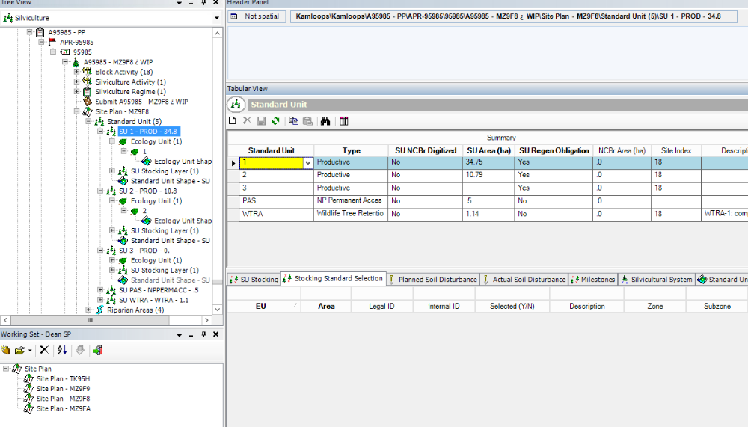
Solution: Under the Eco Unit try to take out the Region and see if the stocking standards show up then.
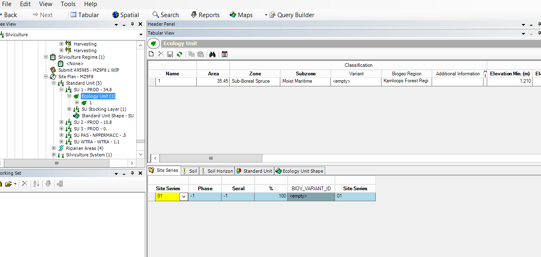

Unable to Save Edits Due to Existing Overlap Issue
Example an existing FLTC polygon over a planned block as shown below.
BCTS GIS staff have the ability to override these spatial validation rule exceptions. If you run into this please submit a GIS request.
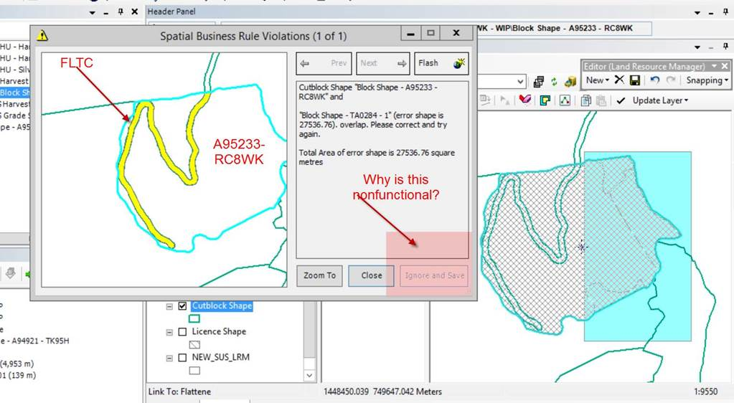

Intersecting Road Violation
You may link spatial for your road and come across the violation in the screenshot below and not be able to see where the self-intersect is happening. There are two ways you can identify this. Method 1 is to check the box in the screenshot below on the routes tab in the road properties. Method 2 is to open up the edit sketch properties you can scan the list and see where the double vertex is happening. You can then delete one of the vertices and save once again.
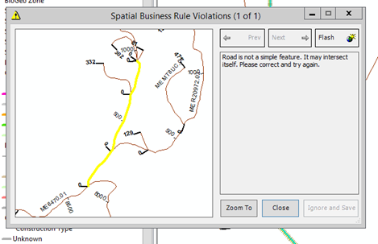
Method 1:
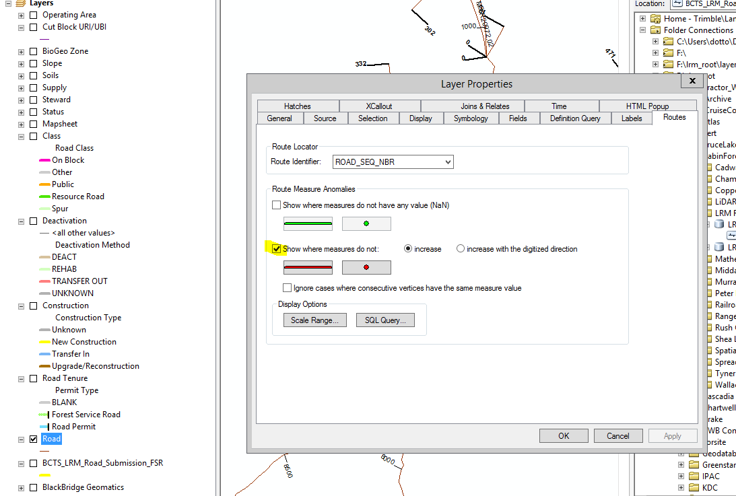
Method 2:
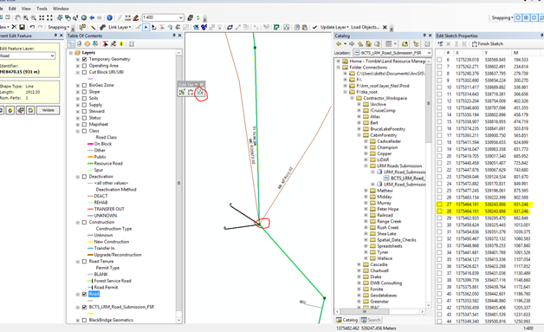

Unable to Insert a Cutblock Shape record on the Block child tab
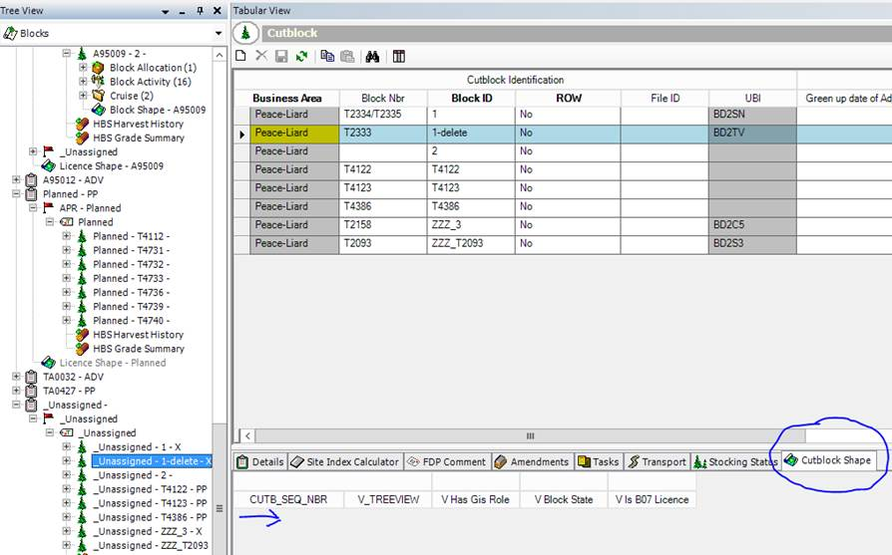
The security group BCTS_BLOCKS_ADMIN now grants this permission. If you are unable to do this and need to contact your LRM ADMIN and have them add you to this security group.

New LRM Users name does not appear in Responsibility dropdowns - RESOLVED
Person Type table was missed in LRM to tie person to responsibility. User must be added to Person Type table via Resources application by an LRM ADMIN.
To Open Resources:
- Right-click the BA node at the top of the Tree View
- Choose Send to External Tool – Resources
- Password is ‘adam’ to log in
Then open the Common Maintenance table and go to the Person table.

Cannot add Road Activity Completed Date without Populating Actual Costs – RESOLVED?
This BIZ rule was added for all road activities in error. It has now been removed for Construction/Deactivation but is still in place for Assessments and Maintenance activities (and maybe others). The temporary work-around is to enter actual costs of 0.01 however, only the Road Engineering staff have the ability to enter road costs.
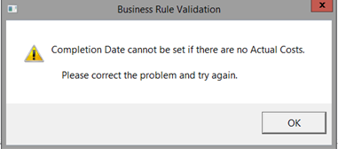

Management Unit Record for Road Does Not Have the Correct TO Value
Attempt to update To value throws Oracle error-20499
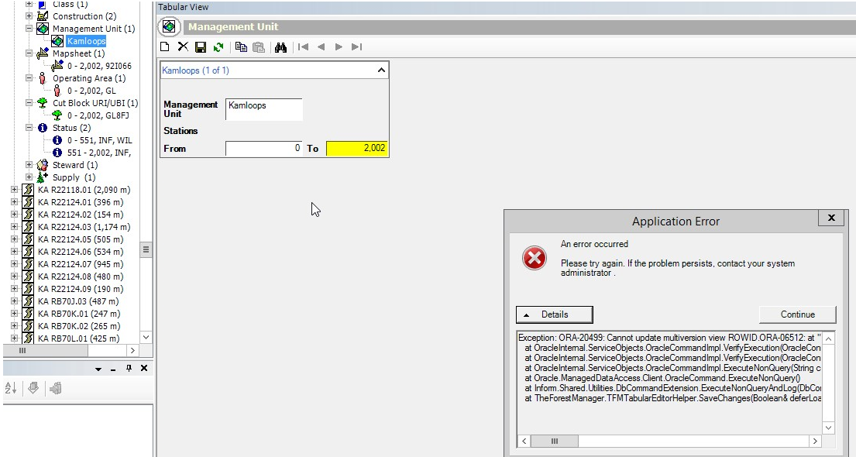
NRS ticket has been submitted. Temporary work-around is to run the road through the Route Event Wizard (make a minor edit) and the overlay will re-run and update with the correct end station.

Overlay Features missing when trying to Populate
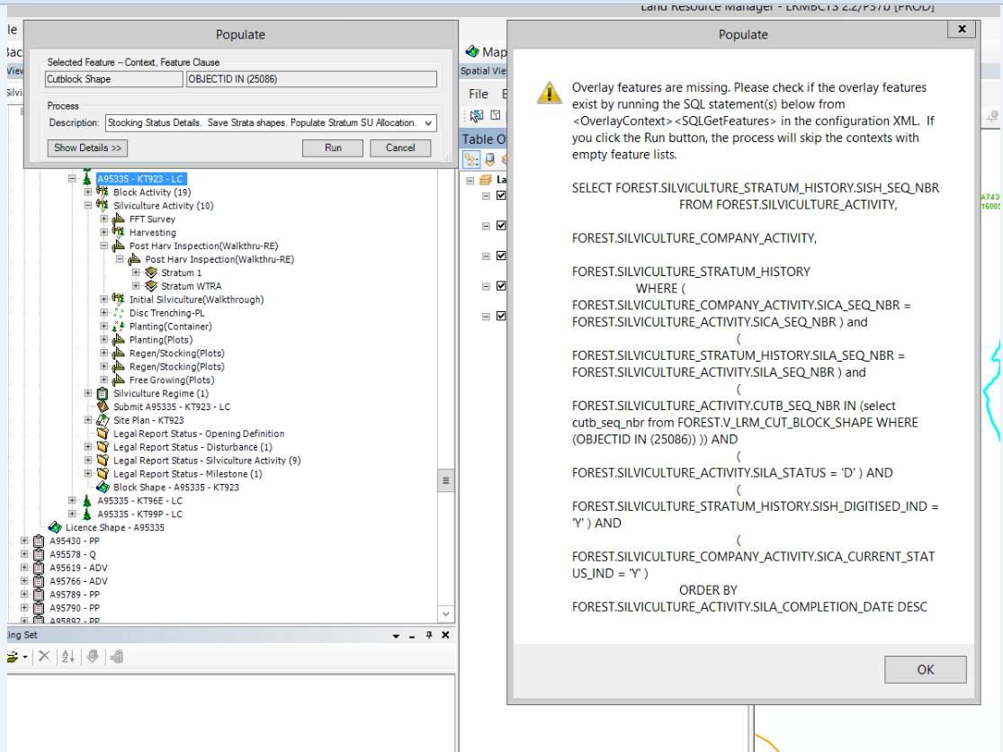
Solution: If you have added the correct shapes to your stratum and still getting the above message make sure you have flipped the “Status” to done in the silviculture activity.
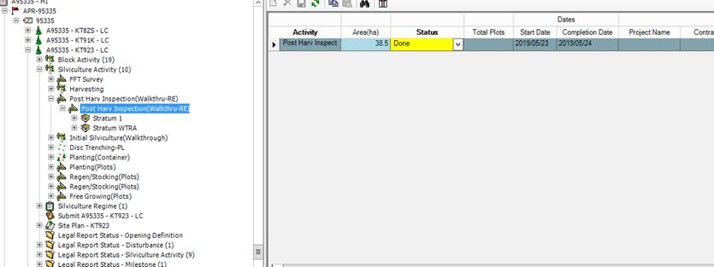

Populate failure
Both below errors seem to occur when there are multiple shape records attached to a tabular record
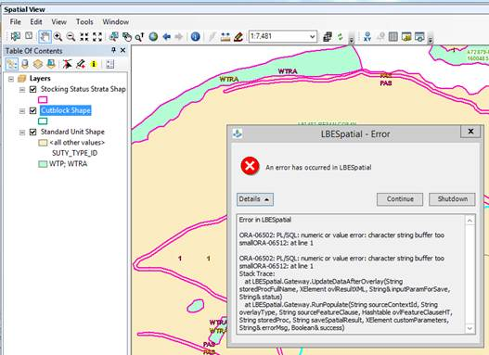
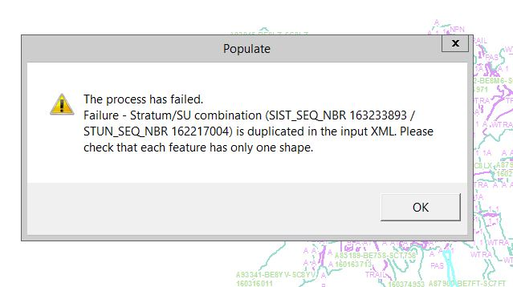
Solution: To solve this look at the activities being pulled by the populate and ensure that they do not have multiple shapes like the screenshot below. If they do you will have to use the link tool to combine all the shapes into one of the shape records, then delete the others.

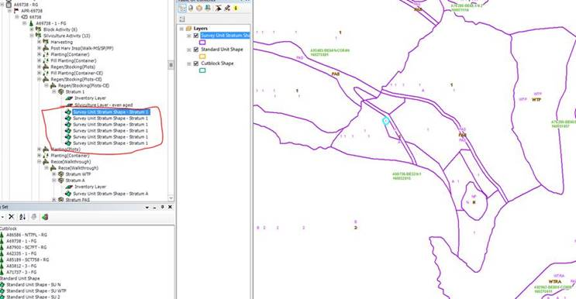

LBE spatial Error when trying to edit
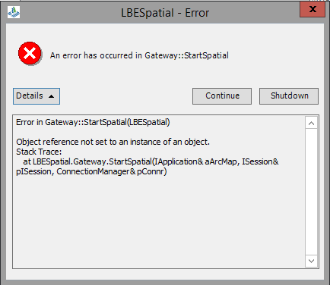
Solution: This one seems to be solved by purging your mxd. You will have to close your spatial view otherwise the purge mxd button will be greyed out. Tools > options > spatial view > purge mxd file.
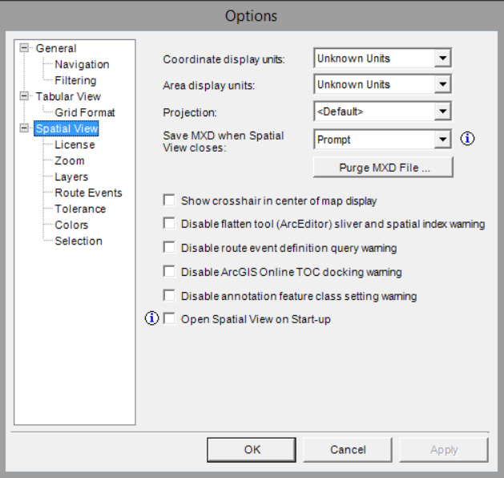

Running route event wizard prompts LBE Spatial error
This error will lock up your LRM and the only way to exit is to log off your LRM session

Solution: Check the road structures and if there is a type field defined in LAT LONG (string or decimal) but no corresponding values in the latitudes and longitudes, that is the problem. This seems to be a problem with older roads and LRM doesn’t know how to deal with it. You can either delete the type or enter lats and longs to resolve the issue.

Application error when trying to update a road record
This is an issue caused by the split tool in LRM. If you have split a road using this tool the tabular records remain linked. It will not let you change the values of the any of the records that were split. The only way past this is to delete the record, which will delete it from both sides of the split and re-create the record from new on both roads. It is not recommended that you use the Split tool for editing roads until this tool is functioning correctly.
